Readme
Project implementation of an AsteriskServer Raspberry Pi and Asterisk
Everything that has occurred to me I have done, or almost everything, on a Raspberry pi, sometimes a friend makes jokes by mentioning the things I do on it, and that's why he says which is a raspberrybomb, of so many things I do in it.

This time the following scenario occurs to me:
use the minutes of my home phone, not even my phone, rather my mother's, yes, like that !!. This applies to the office, so you would have your conventional phone in your pockets.
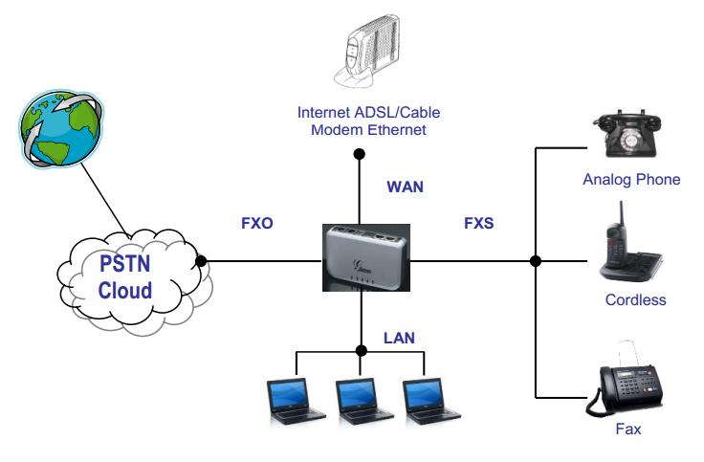

What do we need?
1 Raspberry Pi (in my case 3b)
1 FXO and FXS Gateway (HT503 gramstream)
1 Android / IOS compatible Softphone (Zoiper)
1 Zerotier Client (it's a VPN with minimal effort) this is great!
1 Raspbian lite, 400MB https://www.raspberrypi.org/

Basic parameterization of the Gateway Grandstream HT 503
First of all, we assign it a fixed IP of our local network so that the Raspberry Pi can "locate" it in any case.
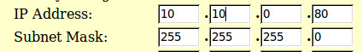
use the following one so that you don't have to modify anything in the files that you download from my repository: 10.0.0.201 is the asterisk server on the raspberry pi, for this it establishes that fixed ip to it.
The ip of the HT503 should be 10.0.0.202
anyway it is good that you do the basic configurations from https://blog.irontec.com/ahorro-telefonico-con-raspberry-pi-y-asterisk/
then look at this material because I added some things that are extra but necessary, it seems that things have changed and this gave me problems, but I solved them for you.
We go to the «FXS» tab and choose the Caller ID Scheme «ETSI-FSK prior to ringing with RP».
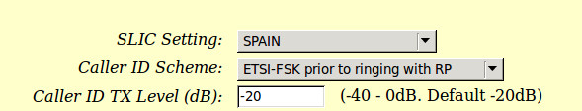
On the other hand, in the «FXO» tab the Caller ID transport will be «Relay via SIP from».
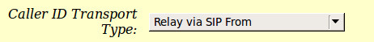
In the "FXO" tab again, we must select "RFC2833" as the main option (then we will have to do the same on the Raspberry Pi)
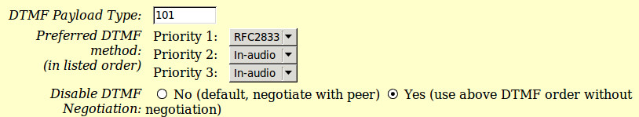

For its part, at the gateway through its web portal, we can indicate the SIP server of record ( the Raspberry), as well as the user. To do this, we go to the "FXO" tab and enter the values.
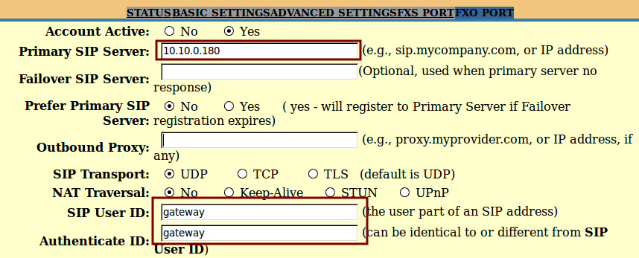
a
Source (https://blog.irontec.com/ahorro-telefonico-con-raspberry-pi-y-asterisk/)
My Improvements:
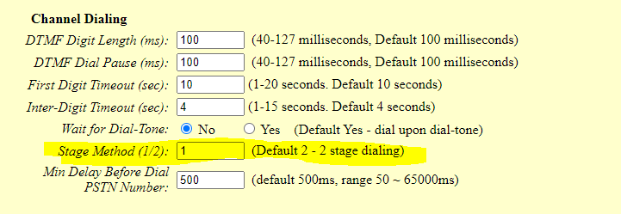
Stage Method (1/2): 1 in thetap FXO PORT
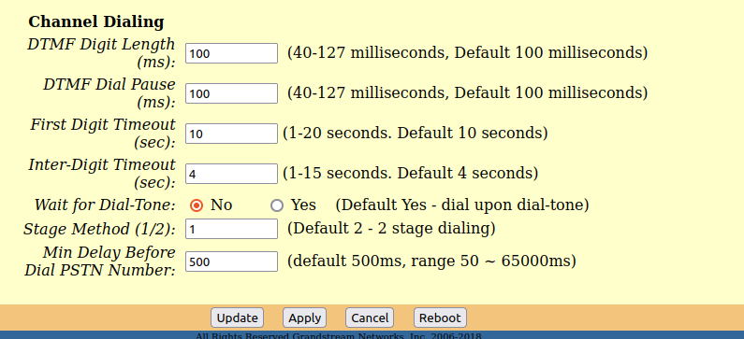

In this part we select Wait for dial-tone = no
in thetap FXO PORT

Update the equipment firmware.grandstream.com
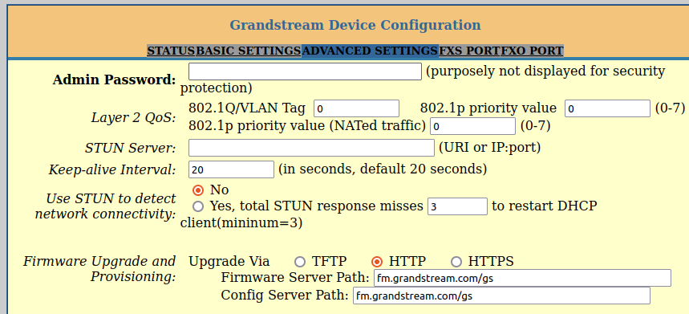

Via telnet
telnet 10.0.0.202
upgrade
upgrade

